Project Design Phase-II
Data Flow Diagram & User Stories

Date | 14 February 2026
Team ID | LTVIP2026TMIDS26598
Project Name | Prevent User Deletion If Assigned to Incident
Maximum Marks | 5 Marks

What is DFD?
A Data Flow Diagram (DFD) represents how data flows inside a system.
It shows:
- How data enters the system
- What process handles the data
- Where data is stored
- How data leaves the system

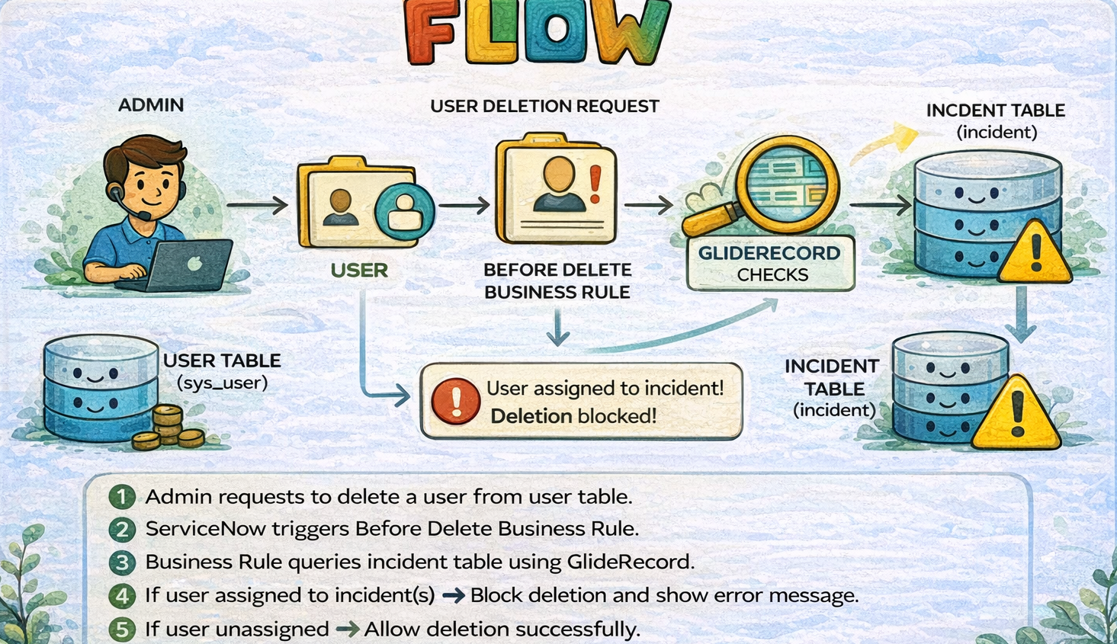

User Stories:
Below are the user stories for our ServiceNow project:
User Type | Functional Requirement (Epic) | User Story No | User Story | Acceptance Criteria | Priority | Release
ServiceNow Admin | User Management | USN-1 | As an admin, I can create a new user in the system. | User record is saved in sys_user table. | High | Sprint-1
ServiceNow Admin | Incident Management | USN-2 | As an admin, I can assign an incident to a user. | Incident record shows assigned user. | High | Sprint-1
ServiceNow Admin | Business Rule Configuration | USN-3 | As an admin, I can create a Before Delete Business Rule. | Business Rule is active and runs before delete. | High | Sprint-2
ServiceNow Admin | Validation | USN-4 | As an admin, I want the system to check if a user is assigned to any incident before deletion. | System queries incident table successfully. | High | Sprint-2
ServiceNow Admin | Data Protection | USN-5 | As an admin, I want deletion to be blocked if user is assigned to an incident. | Error message appears and deletion is prevented. | High | Sprint-2
ServiceNow Admin | Data Integrity | USN-6 | As an admin, I want unassigned users to be deleted successfully. | User is deleted if no incidents assigned. | Medium | Sprint-2
ServiceNow Admin | System Monitoring | USN-7 | As an admin, I can test deletion scenarios. | Assigned user deletion fails; unassigned user deletion succeeds. | Medium | Sprint-3
IT Manager | System Stability | USN-8 | As an IT Manager, I want to ensure workflow continuity. | No incident loses assigned user due to deletion. | High | Sprint-3

